# CS 255 System Design Document Template

This template lays out all the different sections that you need to complete for Project Two. Each section has guidance to prompt your thinking. You will need to continually reference the interview transcript as you work to make sure that you are addressing your client’s needs. There is no required length for the final document. Instead the goal is to complete each section based on what your client’s needs are. Remove this note when you are finished, and replace all bracketed text with the relevant information.

## UML Diagrams

### UML Use Case Diagram

### UML Activity Diagrams

Diagram for student taking a practice test.

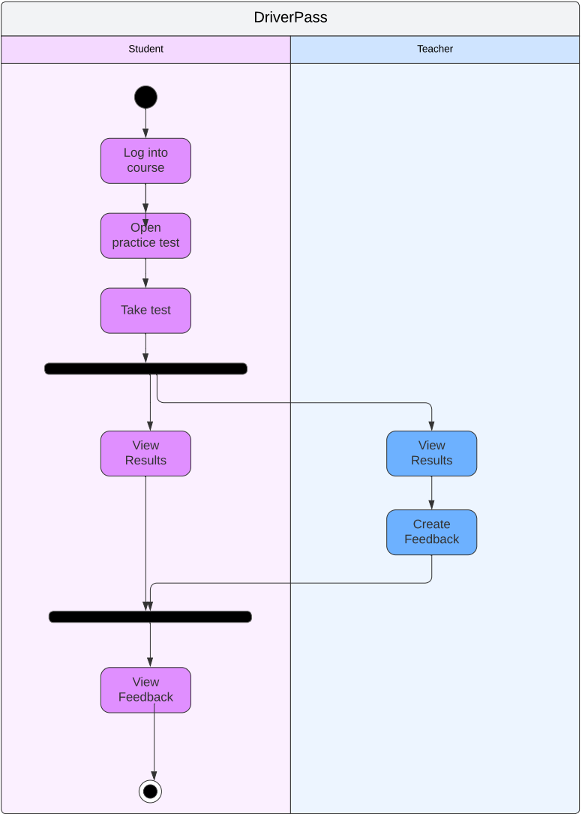

### UML Sequence Diagram

*

### UML Class Diagram

*[You were asked to create a class diagram based on the different classes and attributes needed for your system design. You are* ***not*** *required to include methods, but you may if you wish. Please insert your class diagram here. Check to make sure that you included appropriate components and symbols and that your design meets the client’s requirements.]*

## Technical Requirements

*[Based on the diagrams you have created, describe the technical requirements of your system. These requirements should address the required hardware, software, tools, and infrastructure necessary for your system design.]*